CSC300
Object Oriented Analysis and Design
Assignment 3

1. Identify the most significant misuse cases for the online car rental system. Make sure to specify the abstract, high-level, and expanded misuse cases for those Use cases you describe. Assume these are for a malicious hostile intent to subvert the nominal operation of the rental system.

Misuse Case | Description | Defense
Buffer Overflow | Attacker causes a program to write beyond the bounds of a data object, leading to undesired behavior, e.g., changing the return address stack to cause the system to execute a program for the attacker. | Use safe functions and type safe programming practices like encapsulation. Generate input validation and bounds checking.
Input Manipulation | Attacker manipulates one or more user input elements to cause the system to behave differently | Generate input validation which checks for string manipulation. Sanitize user input, Avoid Using User-Controlled Values in Format Strings, use regex for pattern matching.
Synthetic Identities | Attackers create a synthetic id with real and fake data mixed in to bypass traditional verification systems. | Use ID me service to verify Identifications are authentic. Only IDs that are verified will be able to rent a car.

1. Buffer Overflow - This misuse case involves exploiting a programming error that allows data to overflow the storage area of memory.

- Abstract Misuse Case - failure to enforce memory boundaries allowing an attacker to write to unintended memory locations.

- High-Level Misuse Case - An attacker writes past a buffer's end to overwrite critical program data to redirect program execution flow to malicious code.

- Expanded Misuse Case - An attacker provides input that exceeds the size of a local variable stored on the stack, overwriting the saved pointer and/or the saved return address to point to shellcode injected into the buffer itself, thereby achieving arbitrary code execution.

2. Input Manipulation - This misuse case involves an attacker providing malicious or malformed input to a system to change its intended logic or behavior.
- Abstract Misuse Case – The failure to properly validate, sanitize, or encode user-supplied data before it is processed by the application or included in an internal command/query.

- High-Level Misuse Case – An attacker introduces bad data that is mistakenly interpreted as code, parameters, or control characters by the underlying system component (e.g., database, operating system, or interpreter).

- Expanded Misuse Case - An attacker provides specially crafted input (e.g., in a login form) containing SQL commands that are concatenated into a dynamic SQL query, causing the database to execute the attacker's unintended command (like retrieving all user records or deleting tables).

3. Synthetic Identities - This misuse case involves attackers creating a fraudulent persona using a combination of real and fake information to bypass identity verification.
- Abstract Misuse Case – The failure of identity proofing systems to detect fake, non-existent, or stolen digital and physical attributes used to create a new, seemingly legitimate identity.

- High-Level Misuse Case – An attacker establishes a synthetic identity that meets the minimal verification requirements of a service (like a background check or credit check) to gain unauthorized access to resources (e.g., renting a car, opening a line of credit, or accessing a system).

- Expanded Misuse Case - Financial Fraud, Rental/Service Abuse, Bot-Based Account Creation.

2. Synthesize the domain model of vending machine which has the following characteristics.
Products can be purchased by inserting the correct number of coins into the machine. A user selects a product from a list of available products, adds coins, and either gets the product or gets the coins returned if insufficient money was supplied or if the product is sold out. Products can be restocked and money removed by an operator.
- Write a set of simple requirements for this system
R1 (3) Owner can set item price.
R2 (2) System can verify items in stock.
R3 (1) System can verify Payment.
R4 (5) System can display list of products (prices and stock).
R5 (1) Customer can Purchase Item.
R6 (2) Customer can add coins.
R7 (4) Customer can return coins if no purchase is made.
R9 (1) Owner can remove coins.

- Write a set of key use cases from this description based on the requirements in (i)
  - Vending Machine
    - Owner can add, remove or edit items from inventory
      - Owner can set Items to vending machine inventory.
      - Owner can set stock of items added.
      - Owner can set price of items added.
      - Remove coins from vending machine
    - Customer can:
      - Check vending machine inventory.
      - Add coins to the vending machine.
      - Make purchases using coins.
      - Return coins if too many coins are entered.
      - Return coins if no purchase is made.
    - The System can:
      - Display Inventory.
      - Check if enough coins for the selected item have been inserted.
      - Return excess coins after a purchase.
      - Display out of stock if an item is out of stock.
      - Display needed coins if customer does not insert enough coins for a product.

- Draw a UML Use case diagram of your domain model
- 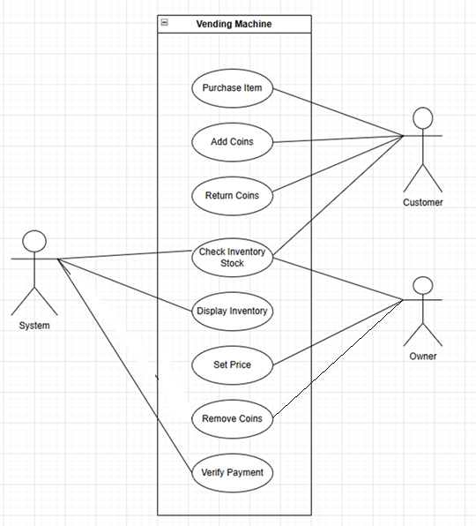

- Draw a UML class diagram of your domain model
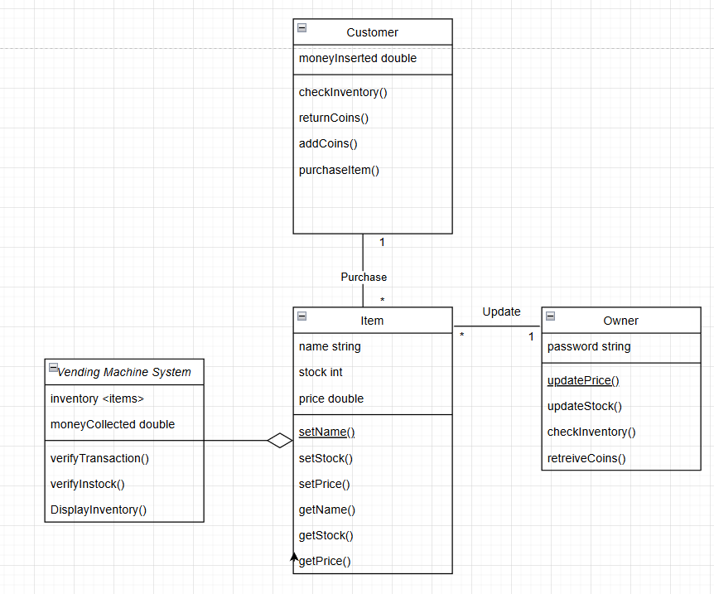

- Create an interaction table for the Use case of a user purchasing a product from the machine.
Actor: Customer | System: Vending Machine
 | - Vending machine displays menu.
- Customer makes a selection. | - System displays price or sold out.
- Customer enters coins | - System Validates if enough coins have been entered. If enough coins entered vend Item else display current Money collected and Price of item

- Create a UML sequence diagram of the use case in (v) above

